**1)Student Mark**

**package** com.student;

**import** java.util.ArrayList;

**import** java.util.Collections;

**import** java.util.Iterator;

**import** java.util.List;

**import** java.util.Scanner;

**public** **class** StudentMarks {

**public** **static** **void** main(String args[]) {

**int** totalNumberOfStudents;

**int** i;

//Creating object of scanner class

Scanner studentInput=**new** Scanner(System.***in***);

System.***out***.println("Enter number of Students ");

totalNumberOfStudents=studentInput.nextInt();

//Loop for taking students marks input

System.***out***.println("Enter Marks ");

List<Integer> marksList=**new** ArrayList<Integer>();

**for**(i=0;i<totalNumberOfStudents;i++) {

marksList.add(studentInput.nextInt());//Storing marks to array list

}

//Output

//For getting the highest mark of the student

System.***out***.println("Highest marks : "+Collections.*max*(marksList));// It prints the highest marks of the student

//For getting the average marks of the student

**float** average=0;

**for**(i=0;i<totalNumberOfStudents;i++) {

average=average+marksList.get(i);

}

System.***out***.println("Average Marks : "+(average/totalNumberOfStudents));

//Displaying the marks of student

**for**(i=0;i<totalNumberOfStudents;i++) {

System.***out***.print((i+1)+"-"+marksList.get(i)+" ");

}

//For getting the third student mark

System.***out***.println("\n3rd Student marks : "+marksList.get(2));

//Student marks in sorted order

System.***out***.print("Sorted : ");

Collections.*sort*(marksList);

Iterator<Integer> iterator=marksList.iterator();

**int** flag=1;

**while**(iterator.hasNext()) {

System.***out***.print(flag+"-"+iterator.next()+" ");

flag=flag+1;

}

}

}

Output:

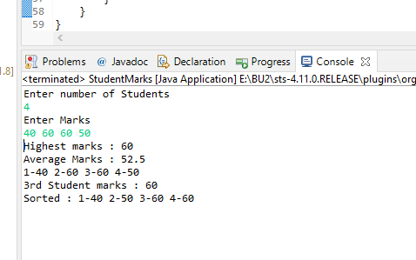

**2) Cricket score analyzer**

**package** com.cricketscore;

**import** java.util.Collections;

**import** java.util.LinkedList;

**import** java.util.List;

**import** java.util.Scanner;

**class** ScoreAnalyzer{

**private** **int** runsData;

**public** ScoreAnalyzer() {

// **TODO** Auto-generated constructor stub

**super**();

}

**public** ScoreAnalyzer(**int** runsData) {

**super**();

**this**.runsData=runsData;

}

//Storing runs in list

List<Integer> runlist=**new** LinkedList<Integer>();

**public** **void** addRunsToList(**int** runsData){

runlist.add(runsData);

}

//Calculate run rate

**public** **float** calcRunRate() {

**float** runRate=0;

**for**(**int** i=0;i<5;i++) {

runRate=runRate+runlist.get(i);

}

**return** (runRate/50);

}

//Lowest run scored by player

**public** **int** lowestRunsScored() {

**int** lowestrun=Collections.*min*(runlist);

**return** lowestrun;

}

//Display all runs

**public** **void** displayRuns() {

**int** i=1;

**for**(Integer run:runlist){

System.***out***.print(i+"-"+run+" ");

i=i+1;

}

}

//Getter and Setter

**public** **int** getRunsData() {

**return** runsData;

}

**public** **void** setRunsData(**int** runsData) {

**this**.runsData = runsData;

}

}

**public** **class** TestScoreAnalyzer {

**public** **static** **void** main(String args[]) {

**int** i;

ScoreAnalyzer analyzer=**new** ScoreAnalyzer();

Scanner input=**new** Scanner(System.***in***);

System.***out***.println("Enter Runs ");

**for**(i=0;i<5;i++) {

**int** runInputByPlayer=input.nextInt();

analyzer.addRunsToList(runInputByPlayer);

}

//For displaying record

analyzer.displayRuns();

System.***out***.println("\nRunrate : "+analyzer.calcRunRate());

System.***out***.println("Lowest Runs : "+(analyzer.lowestRunsScored()));

System.***out***.println("Count of player who batted : "+analyzer.runlist.size());

}

}

**Output:** 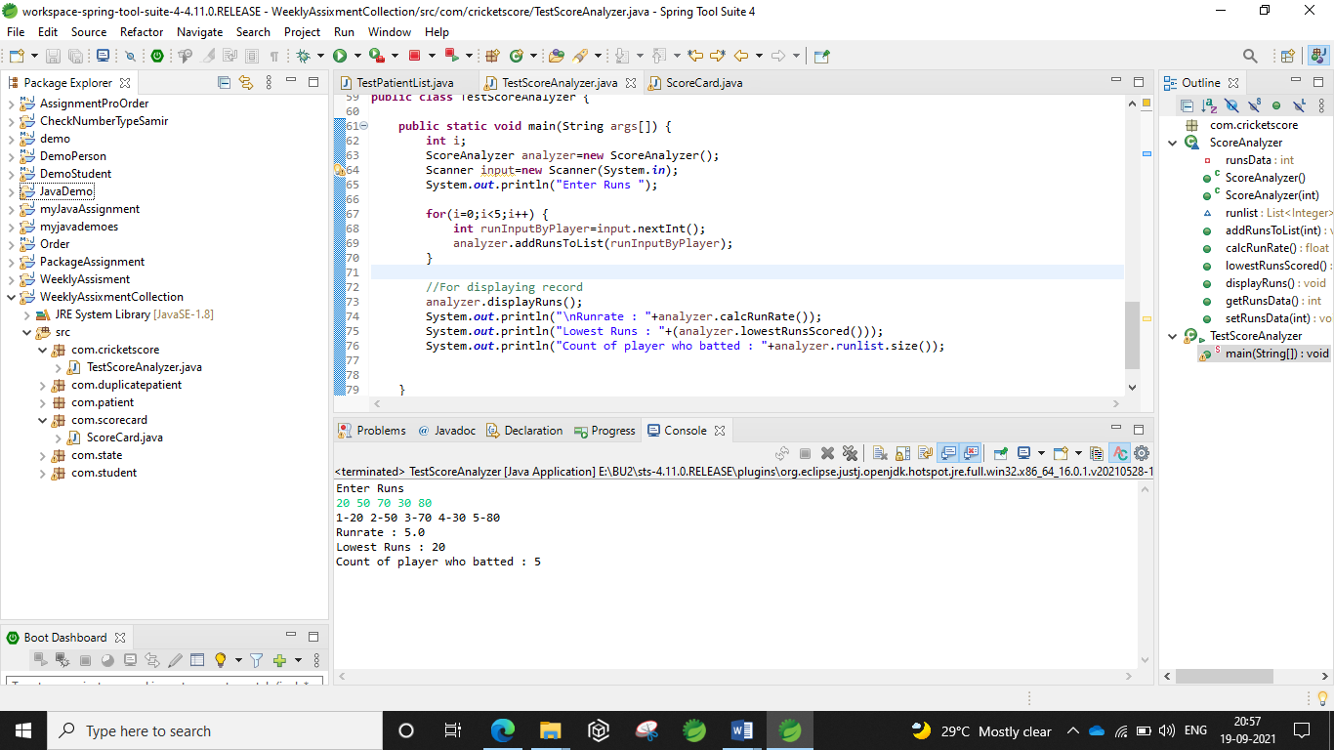

**3) Scorecard**

**package** com.scorecard;

**import** java.util.Collections;

**import** java.util.HashMap;

**import** java.util.Iterator;

**import** java.util.Map;

**import** java.util.Scanner;

**public** **class** ScoreCard {

**public** **static** **void** main(String args[]) {

Map<String,Integer> batsmanscore=**new** HashMap<String,Integer>();

Scanner input=**new** Scanner(System.***in***);

System.***out***.println("Enter runs scored");

**for**(**int** i=0;i<5;i++) {

String nameRun[]=input.next().split("-");

String name=nameRun[0];

**int** run=Integer.*parseInt*(nameRun[1]);

batsmanscore.put(name, run);

}

//Name of players who have batted

System.***out***.println("Players who batted ");

Iterator<String> iterator=batsmanscore.keySet().iterator();

**while**(iterator.hasNext()) {

String name=iterator.next();

Integer run=batsmanscore.get(name);

System.***out***.println(name);

}

**int** runByDhoni=0;

**int** totalruns=0;

System.***out***.println("Scores by Players ");

Iterator<String> iterator1=batsmanscore.keySet().iterator();

**while**(iterator1.hasNext()) {

String name=iterator1.next();

Integer run=batsmanscore.get(name);

System.***out***.println(name+" : "+run);

totalruns=totalruns+run;

**if**(name.equalsIgnoreCase("Dhoni")) {

runByDhoni=run;

}

}

System.***out***.println("Total Score : "+totalruns);

**int** maxRun=Collections.*max*(batsmanscore.values());

Iterator<String> iterator3=batsmanscore.keySet().iterator();

**while**(iterator3.hasNext()) {

String name=iterator3.next();

Integer run=batsmanscore.get(name);

**if**(run==maxRun) {

System.***out***.println("Name of Highest Scorer : "+name);

}

}

//Run scored by Dhoni

System.***out***.println("Runs Scored by Dhoni : "+runByDhoni);

}

}

**Output:**

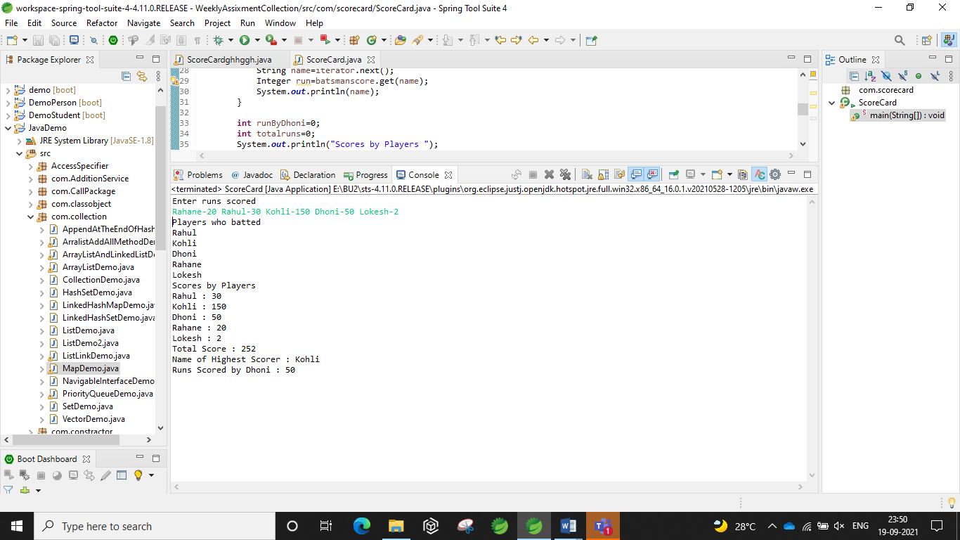

**4) Patient List**

**package com.patient;**

**import java.util.ArrayList;**

**import java.util.Collections;**

**import java.util.Comparator;**

**import java.util.Iterator;**

**import java.util.List;**

**import java.util.TreeSet;**

**class Patient implements Comparable<Patient>{**

**private int patientId;**

**private String name;**

**private int age;**

**//Parameterized constructor**

**public Patient(int patientId,String name,int age) {**

**super();**

**this.patientId=patientId;**

**this.name=name;**

**this.age=age;**

**}**

**//Getters / Setters**

**public int getPatientId() {**

**return patientId;**

**}**

**public void setPatientId(int patientId) {**

**this.patientId = patientId;**

**}**

**public String getName() {**

**return name;**

**}**

**public void setName(String name) {**

**this.name = name;**

**}**

**public int getAge() {**

**return age;**

**}**

**public void setAge(int age) {**

**this.age = age;**

**}**

**//TreeSet**

**@Override**

**public int compareTo(Patient patient) {**

**// TODO Auto-generated method stub**

**if(this.patientId==patient.getPatientId()) {**

**return 0;**

**}**

**else if(this.patientId>patient.getPatientId()) {**

**return 1;**

**}**

**else {**

**return -1;**

**}**

**}**

**}**

**public class TestPatientList {**

**public static int getPatientAge(String name,TreeSet listofpatient) {**

**int age=0;**

**Iterator<Patient> itr=listofpatient.iterator();**

**while(itr.hasNext()) {**

**Patient patient=itr.next();**

**if(patient.getName()==name) {**

**age=patient.getAge();**

**}**

**}**

**return age;**

**}**

**public static void main(String args[]) {**

**//List<String> li=new ArrayList<String>();**

**List<Patient> patientList=new ArrayList<Patient>();**

**patientList.add(new Patient(1, "Rakesh", 19));**

**patientList.add(new Patient(2, "Amrita", 18));**

**patientList.add(new Patient(3, "GyanPratp", 23));**

**//Storing patient list by name sort**

**Collections.sort(patientList,new Comparator<Patient>(){**

**public int compare(Patient p1,Patient p2) {**

**return p1.getName().compareTo(p2.getName());**

**}**

**});**

**System.out.println("Sorting the patient by there name : ");**

**for(Patient patient:patientList) {**

**System.out.println("Patient id : "+patient.getPatientId()+", Patient name : "+patient.getName()+", Patient age : "+patient.getAge());**

**}**

**//Storing patient list by age sort**

**Collections.sort(patientList,new Comparator<Patient>(){**

**public int compare(Patient p1,Patient p2) {**

**return Integer.valueOf(p1.getAge()).compareTo(p2.getAge());**

**}**

**});**

**System.out.println("\nSorting the patient by there age : ");**

**Iterator<Patient> iterator= patientList.iterator();**

**while(iterator.hasNext()) {**

**Patient p=iterator.next();**

**System.out.println("Patient id : "+p.getPatientId()+", Patient name : "+p.getName()+", Patient age : "+p.getAge());**

**}**

**//Adding all object to tree set**

**TreeSet<Patient> listofpatientintreeset=new TreeSet<Patient>(patientList);**

**//Traversing patient list**

**System.out.println("\nTraversing patient list from tree set");**

**for(Patient patient1:listofpatientintreeset) {**

**System.out.println("Patient id : "+patient1.getPatientId()+", Patient name : "+patient1.getName()+", Patient age : "+patient1.getAge());**

**}**

**int age=getPatientAge("Rakesh",listofpatientintreeset);**

**System.out.println("\nAge of the given patient is : "+age);**

**}**

**}**

**Output:**

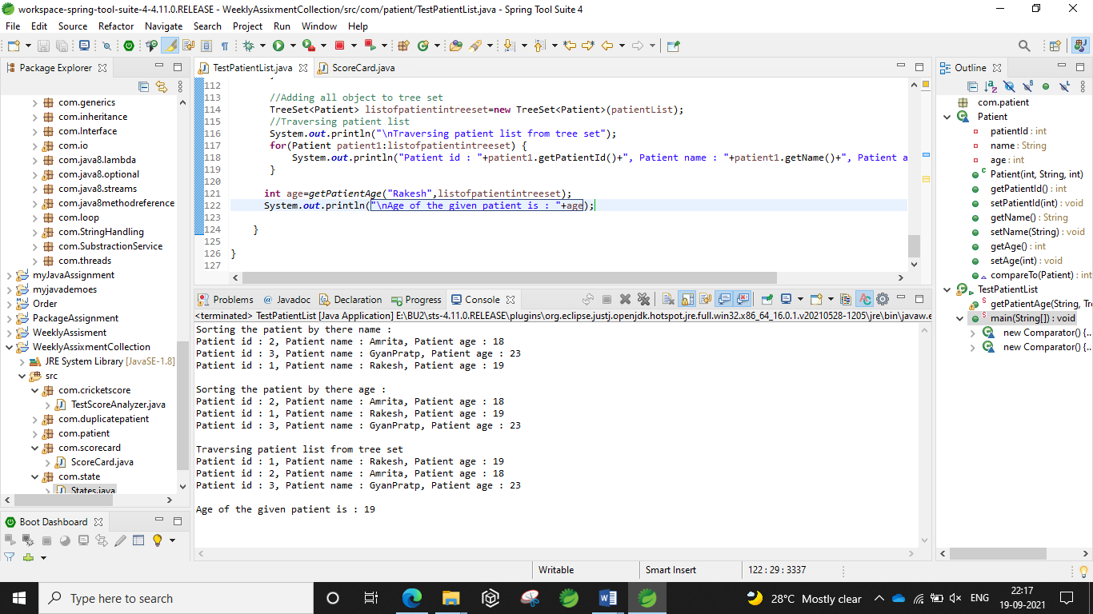

**5) Duplicate Patient**

**package** com.duplicatepatient;

**import** java.util.Iterator;

**import** java.util.LinkedHashSet;

**import** java.util.Set;

**class** Patient{

**private** **int** patientId;

**private** String name;

**private** **int** age;

//Parameterized constructor

**public** Patient(**int** patientId,String name,**int** age) {

**this**.patientId=patientId;

**this**.name=name;

**this**.age=age;

}

//Getters / Setters

**public** **int** getPatientId() {

**return** patientId;

}

**public** **void** setPatientId(**int** patientId) {

**this**.patientId = patientId;

}

**public** String getName() {

**return** name;

}

**public** **void** setName(String name) {

**this**.name = name;

}

**public** **int** getAge() {

**return** age;

}

**public** **void** setAge(**int** age) {

**this**.age = age;

}

}

**public** **class** TestPatientSet {

**public** **static** **void** main(String args[]) {

Set<Patient> patientset=**new** LinkedHashSet<Patient>();

patientset.add(**new** Patient(1, "Rakesh", 19));

patientset.add(**new** Patient(2, "Amrita", 22));

patientset.add(**new** Patient(2, "Amrita", 22));

System.***out***.println("Size of set is : "+patientset.size());

**for**(Patient patient:patientset) {

System.***out***.println("Id : "+patient.getPatientId()+" Patient Name : "+patient.getName()+" Patient age : "+patient.getAge());

}

}

}

**Output :**

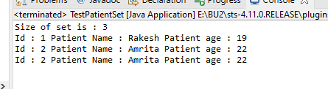

**6)States**

**package com.state;**

**import java.io.BufferedReader;**

**import java.io.FileReader;**

**import java.io.IOException;**

**import java.util.ArrayList;**

**import java.util.Collections;**

**import java.util.LinkedHashSet;**

**import java.util.List;**

**import java.util.Set;**

**import java.util.concurrent.ArrayBlockingQueue;**

**public class States {**

**public static void main(String args[])throws IOException {**

**FileReader fileReader=new FileReader("E:/io/States.txt");**

**BufferedReader bufferedReader=new BufferedReader(fileReader);**

**Set<String> stateSet=new LinkedHashSet<String>();**

**try {**

**String reader=bufferedReader.readLine();**

**//Traversing data from the file one by one**

**while(reader!=null) {**

**stateSet.add(reader);**

**reader=bufferedReader.readLine();**

**}**

**System.out.println("Total number of states : "+stateSet.size());**

**System.out.println("Removing state delhi : "+stateSet.remove("Delhi"));**

**System.out.println("After removing the Delhi : "+stateSet);**

**System.out.print("State which starts with k : ");**

**for(String state: stateSet) {**

**if(state.charAt(0)=='K' || state.charAt(0)=='k') {**

**System.out.print(state+" ");**

**}**

**}**

**//Sorting state in another set**

**List<String> stateList=new ArrayList<String>(stateSet);**

**Collections.sort(stateList);**

**Set<String> statesort=new LinkedHashSet<>(stateList);**

**System.out.println("\nStates in sorted order : "+statesort);**

**}**

**finally {**

**bufferedReader.close();**

**}**

**}**

**}**

**Output :**

